PRACTICAL 10 : Storing Real-Time Data in Firebase

Aim : To store real-time sensor data in Firebase using Arduino and NodeMCU. (Optional)

Overview :
This project involves interfacing a sensor with Firebase using Arduino and NodeMCU to store real-time sensor data in a cloud database. It introduces IoT cloud computing, real-time database integration and data retrieval for smart applications.

Materials Required :
- Arduino Uno R3
- 2 x 1 kΩ Resistor
- Temperature Sensor (TMP36)
- Wifi Module (ESP8266)
- Jumper Wires
- Arduino IDE (Installed on your Computer)

Circuit Connection and Steps :
- Power Connections :
  - TMP36 VCC → 5V (Arduino), GND → GND (Arduino)
  - ESP8266 VCC & CH_PD → 3.3V (Arduino), GND → GND (Arduino)
- Sensor & ESP8266 Wiring :
  - TMP36 VOUT → A0 (Arduino)
  - ESP8266 TX → RX (Arduino) via 1kΩ resistor
  - ESP8266 RX → TX (Arduino) via voltage divider (two 1kΩ resistors)

Circuit Diagram :
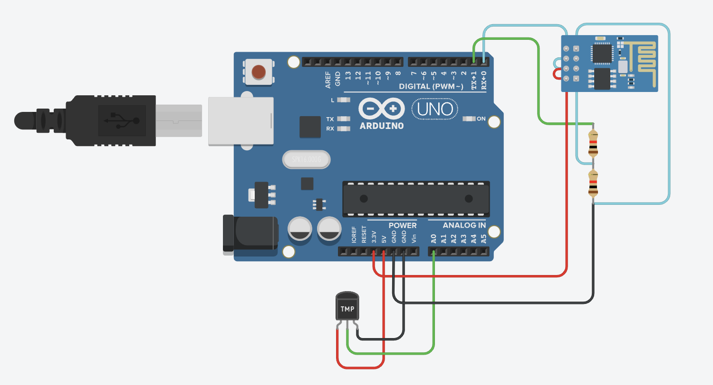

Schematic Diagram :
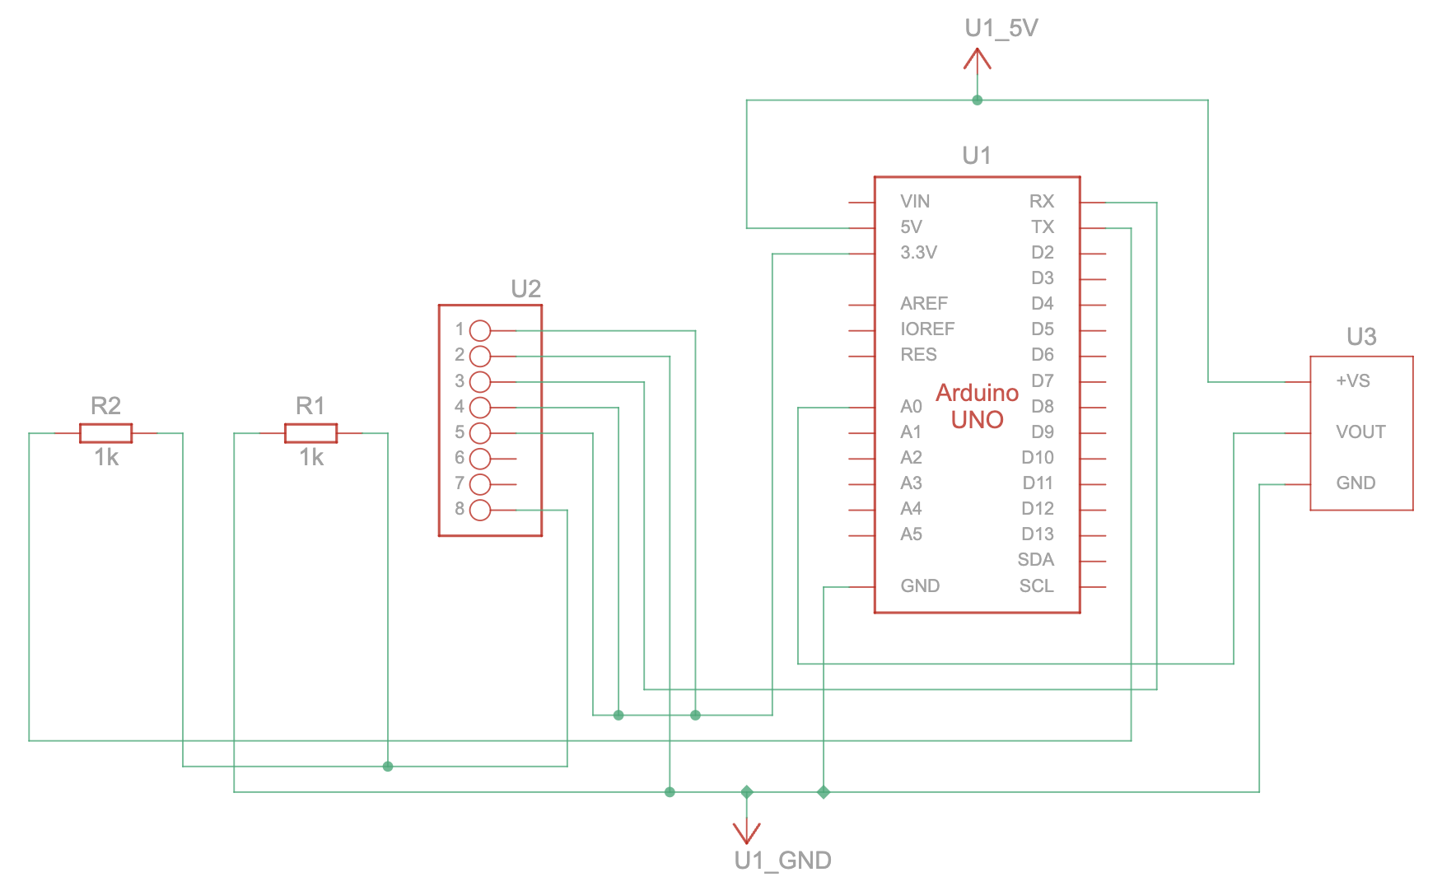

Code :
// WiFi Credentials
String ssid = "Simulator Wifi";
String password = "";

// Firebase Configuration
String host = "realtime-database-iot-default-rtdb.asia-southeast1.firebasedatabase.app";
const int httpPort = 80;
String firebasePath = "/Temperature.json"; // Firebase RTDB Path
String firebaseAuth = "uLsBh7JKrBOSQY8IsnmjOrFB58xZ8ZZABLT708Qv";

// Sensor Pin
const int tempPin = A0;

void setup() {
Serial.begin(115200);
Serial.println("AT"); // Check ESP8266 response
delay(500);

// Connect to WiFi using AT commands
Serial.println("AT+CWJAP=\"" + ssid + "\",\"" + password + "\"");
delay(5000);

// Establish TCP Connection with Firebase
Serial.println("AT+CIPSTART=\"TCP\",\"" + host + "\"," + String(httpPort));
delay(500);
}

void loop() {
// Read Temperature Sensor
float temperature = ((analogRead(tempPin) * 0.0048828125) - 0.5) * 100;

// Construct HTTP request for Firebase
String httpRequest = "POST " + firebasePath + "?auth=" + firebaseAuth +
" HTTP/1.1\r\nHost: " + host + "\r\nContent-Type: application/json\r\n" +
"Content-Length: " + String(String(temperature).length() + 14) + "\r\n\r\n" +
"{\"value\": " + String(temperature) + "}";

// Send Data to Firebase
Serial.println("AT+CIPSEND=" + String(httpRequest.length()));
delay(500);
Serial.println(httpRequest);
delay(5000);
}

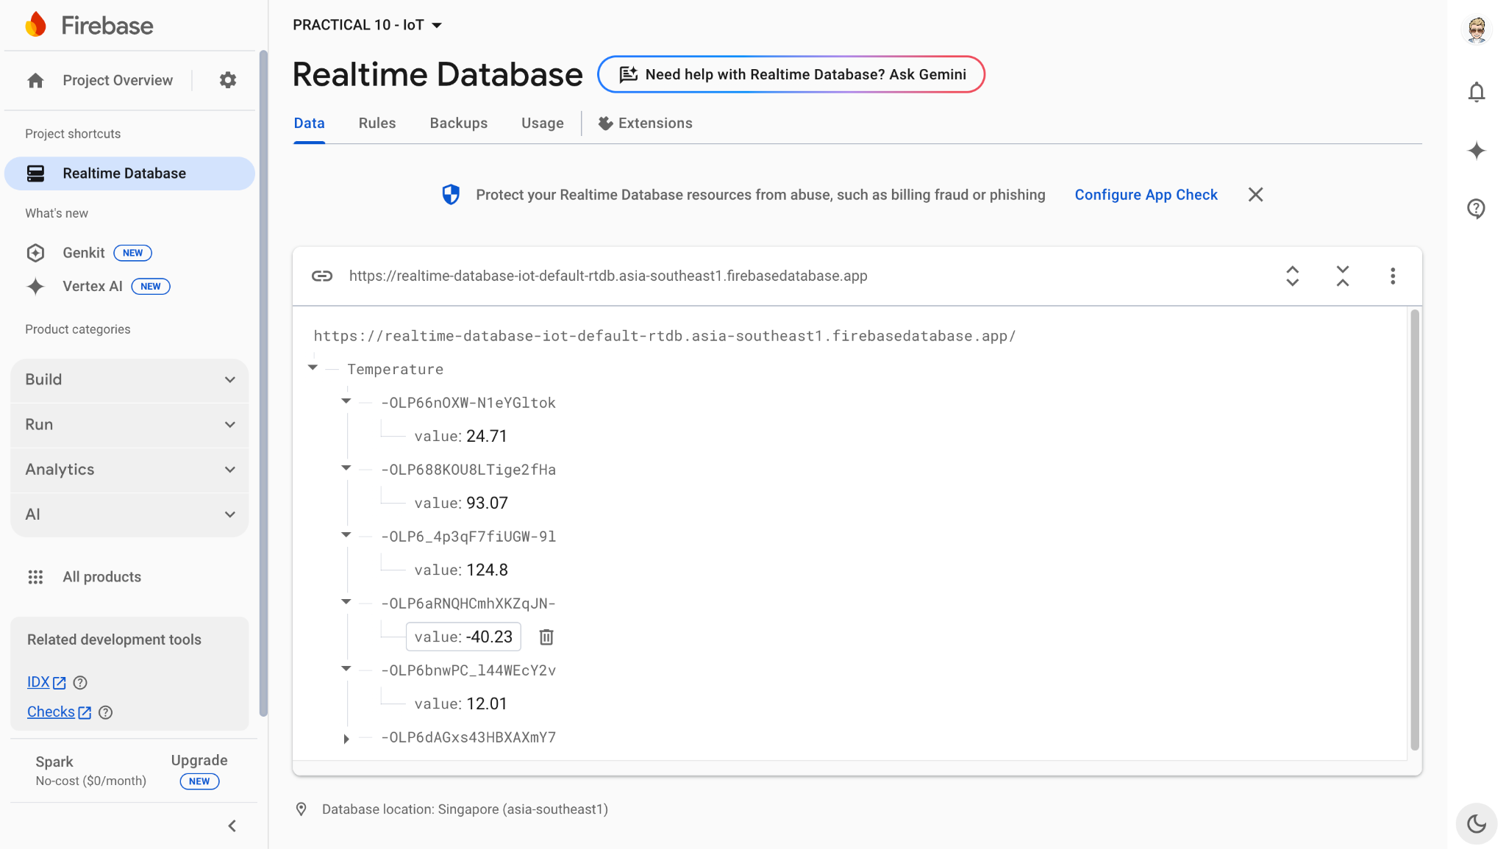
Results :
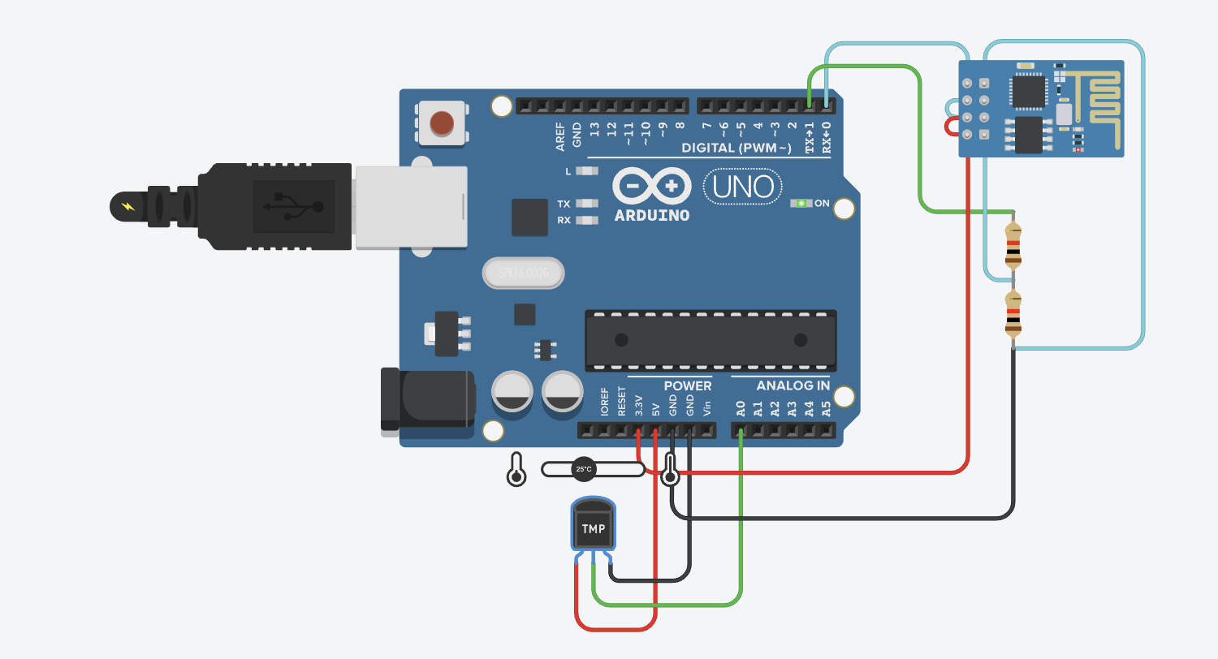

Conclusion :
This project successfully stores real-time sensor data in Firebase using Arduino and NodeMCU. It introduces the concept of cloud storage and real-time database management, forming a critical step toward developing smart IoT systems for data logging and remote access applications.

